February 2016

About Development Initiatives (DEVIN)
The Development Initiatives (DEVIN) is a leading Community Development Non-Governmental organization with headquarters in Port Harcourt, Nigeria. The organization is created to providing sound, systematic and result oriented strategic framework and direction in development programs towards building the capacities of organization and groups. In providing community development services to the rural and urban peoples of Nigeria, DEVIN utilizes professional skills towards strengthening the capacity and participation of the local people in the efforts to develop themselves. As a development-based organization DEVIN acts as conduit for transfer of knowledge through awareness and capacity building, policy advice, exchange of information on sustainable community development practices and innovative skills application.

Integral in the activities of DEVIN is the organization’s contributions to the synergy between donors and the rural and urban communities. In this regard, DEVIN ensures that donor efforts in promoting local initiatives for sustainable community efforts are guided by sound professional and people involved implementation strategies, towards registering the most impact. Established in 1996, DEVIN is registered with the Nigeria Corporate Affairs Commission, under companies and allied matters decree No. 1, 1990 (Part C – Incorporated Trustees) Decree. Presently in Nigeria, the organization is in collaboration with NGOs, Corporate institutions, local / international and other development agencies. DEVIN currently works with hundreds of rural and urban, cooperatives and other community based organizations (CBOs) in the River Niger Delta region.

Offices of Development Initiatives (DEVIN)
Port Harcourt H/Q:
NO 7 Wilfred Ugwunali
Street (Opposite Lone Star Company) Igwurita road Rumukrushi ,
P.O Box 13836 Port Harcourt Phone –08172233183; 08033393027
E-mail: devinitiatives@yahoo.com
www.devinnigeria.org

Abonnema Project Office:
First Building (Two Storey) Agbani Bakery Road, Abonnema
Rivers State.
Phone – 09034657528
E-mail : devinitiatives@yahoo.com
www.devinitiatives.org

Port Harcourt Field Office:
1 Singlet Avenue, off NDDC Road,
Elimnigwe Estate Phase
Phone – 08037957469
E-mail : devinitiatives@yahoo.com
www.devinitiatives.org

Our Contacts

Background and Justification
Niger Graduates’ Entrepreneurial and Wealth Creation Scheme
The dangers posed by youth unemployment are legion. The situation leads to cycles of poverty which the victims inextricably try to escape and in most situations unsuccessful. The frustrations associated with the trend appear to force the youths into acts which tend to go against societal norms and behavior standards. 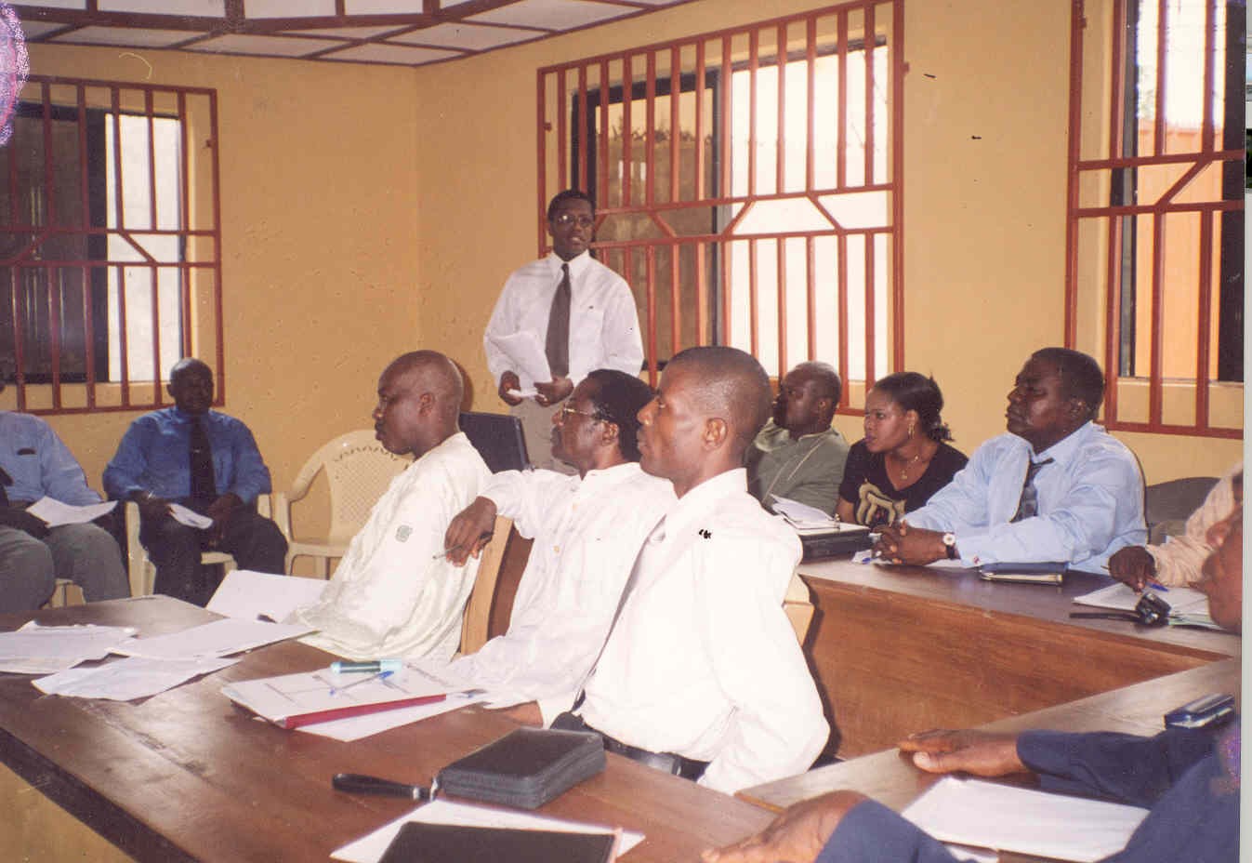However survival is the name of the game as majority of the unemployed youths struggle to eke out a living which guarantees that they meet the essentials of daily life – feeding, clothing, shelter etc. Some of their rather negative indulgences are clearly anti-social and unacceptable to norms of civilized society. However the contradictions about expectations of societies regarding what is right or wrong and how societies ensure dominance of rights over wrongs are glaring. The absence of a system of social security and other welfare schemes in our society seems to limit social safety nets to dependency on extended family system which is currently buckling under weakening and tight economic environment.
In the recent past the residents of Niger and the country at large have been inundated with reports of insecurity and other criminal activities which are perpetuated by mainly the youth. The magnitude and intensity of the crimes has relegated as “acceptable/ manageable” such anti social behaviours like prostitution and robbery and therefore less conscience pricking. In the event of kidnapping, assassinations and outright terrorism other crimes with equally dire consequences assume back stages and considered less ‘news worthy’. That is how far we have retrogressed as a society.
Presently the involvement of youths with University degrees and diplomas in criminal activities are less, but with fewer jobs available how long the situation can hold is uncertain. When youths who are graduates are unemployed it tends to send wrong signals to other youths that there are little or no benefits in striving to achieve good education. Other alternatives which in some cases are inimical to the progress of the society then assume livelihood options.
The consequences of such acts and engagements as noted above continue to retard the attainment of goals that support better life for all. Towards preventing mass involvement of graduate youths in high profile criminal activities which also could add some intellectual sophistication to planning and execution of criminal activities, the need to check rising rate of unemployment among graduates of universities and polytechnics has therefore become overarching in Niger state.
The Proposed Graduate Empowerment Scheme
The Development Initiatives Nigeria (DEVIN) hereby proposes to the Government of Niger State a concept on Niger State Graduate Youth Empowerment Scheme. The proposed scheme aims at providing mass employment to teeming graduates of Niger State origin through series of inter related activities designed for that purpose. The beneficiaries would receive support in terms of robust capacity building that would enable them to individually or jointly run thriving small businesses. 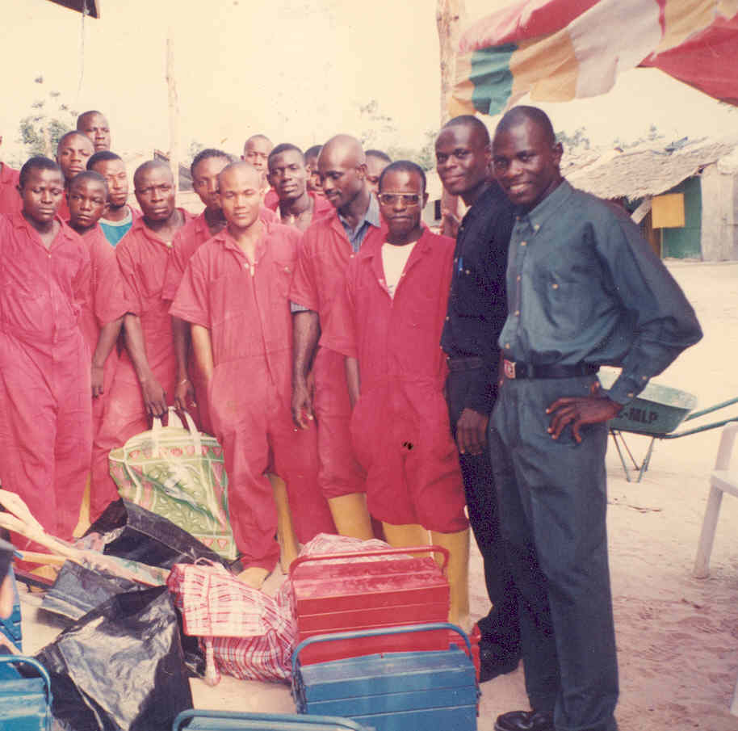Upon completion of this multiple level training, the beneficiaries would be supported to establish small and micro enterprises in such trade lines as Telecommunications / Internet; Agricultural production / harvests processing (crop, animal husbandry and fisheries); Solar technology appreciation and application; Catering / Events management; Tourism / Relaxation spots; Advertising, Printing / Mass media; Private Schools initiatives / Day care centers etc. The proposed business areas are not limited to traditional vocational skills trades but are deliberately extended to reflect and or encompass the envisaged educational diversity and business interest’s divergence of the would – be beneficiaries. Where appropriate, technologies that are in tandem with global aspiration and directions such as the solar technology would be harnessed and deployed to support the businesses to be established.
Intervention objective-
The programme has the overall goal of harnessing the latent entrepreneurial drive and energy of selected unemployed graduates for the purposes of creating mass businesses in Niger State and creating mass employment for University and Polytechnic graduates of Niger State towards poverty reduction and peace building. Specifically the project will realize the following objectives –
Providing technical skills to the graduates on varied trade lines;
Training the beneficiaries on Small business management;
Training youths on appreciation and application of alternative energy sources;
Change of mind-set / attitude re-orientation;
Set up lots of Niger State graduates’ owned and managed small businesses across LGAs of the State;
Create a conducive environment / put in place enabling structures for emergence of future business leaders from the State
Create mass employment courtesy of the businesses that would mushroom across the States;
Reduce youth poverty and restore hope among youths ofNiger State.
Initiate the process of reversing the current trend of youth involvement in high level violent crimes;
Initiate the process of restoring the previous status of Niger State as Investors haven as violent crimes abate;
Activities
Identification, Selection and Classification of Target Beneficiaries
Facilitation of the process of Enterprises Advisory Services /Counseling for Selected Beneficiaries
Selected Beneficiaries Identify Enterprises /Trade lines
Categorization and formation of the Youths into Enterprises leagues ( Groups) in line with their chosen trade lines
Training the Beneficiaries on technical issues along their Enterprises lines
Training the Beneficiaries on Small Business Management Training
Training Graduate Youths on Solar Energy application in connection with their Proposed Enterprises Engagement
Facilitate the Setting up of a Solar Energy powered Enterprises for the Beneficiaries/ Enterprises Hand over to the Beneficiaries
Monitoring/Evaluation
Project Hand over
Strategy-
The beneficiaries would receive support in terms of robust capacity building that would enable them to individually or jointly run thriving small businesses. Upon completion of a multiple level training, the beneficiaries would be supported to establish small and micro enterprises in Niger State
Expected Outcome-
-After implementation of the programme for a year X number of graduates would have been trained in lucrative entrepreneurial skills in Niger State (X number per LGA)
- In the second year of programme at least X number of businesses with potentials of employing 3 employees each would have been set up in Niger State.
-At the end of the second year, a significant percentage would have been added to the working population in Niger State who are self employed.
Budget
A detailed phased budget will be determined when the number of beneficiaries to be enlisted in the scheme is known. The budget would include administrative, logistics, vocational / technical training, small business management training, setting up of small businesses for the scheme participants, programme monitoring etc.
Work Plan
A time guided activity work plan (to accompany a more detailed proposal) will be presented to the Niger State government as soon as the number of beneficiaries are ascertained and approval for the programme given.
Background and Justification
Agricultural Support Programme for Peasant Farmers
The importance and role of the agricultural sector to improved food security, resource employment and poverty reduction in Niger State cannot be over-emphasized. Agriculture beyond its traditional roles also contributes significantly to foreign exchange earnings, gross domestic products, and the overall economic development. The agricultural sector is a huge employer of people especially low literate women and men. The sector in the State is yet to attain optimal productive potentials since existing farming techniques are not only rudimentary but also targeted majorly at realizing subsistence demands. 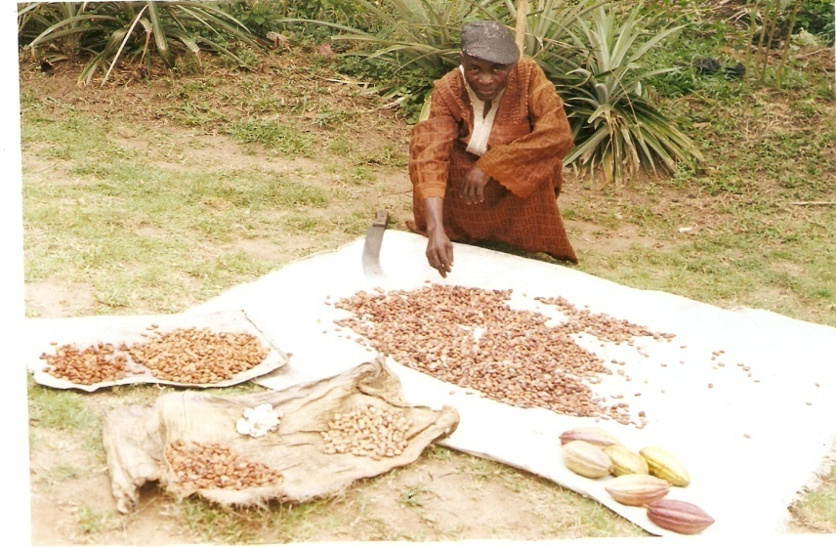The status quo makes the agricultural sector less attractive to especially young men and women who possess energy and drive to make significant difference. Even the older generations whose primary occupation is farming are not supported with incentives such as modern farming techniques and tools to boost production. 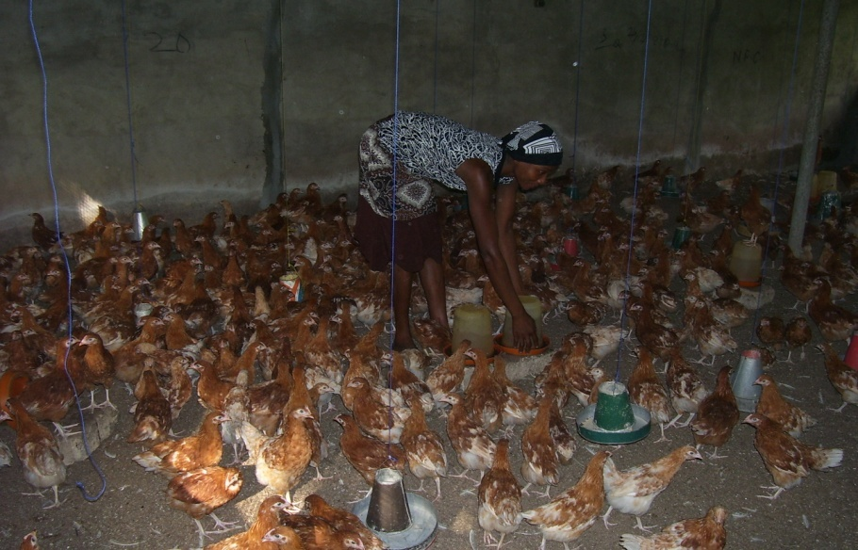The change that could revolutionalize the agricultural sector in Niger State would come with the emergence of a programme that would address some of the identified weaknesses inhibiting the growth of the sector presently and stimulate the involvement of the youths in commercial agricultural activities. 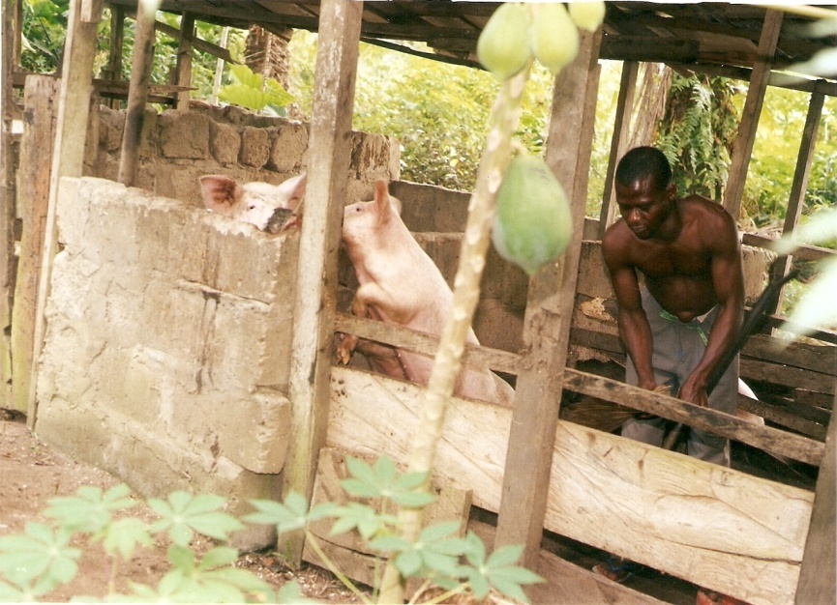Presently majority of the graduates of agricultural disciplines in the State are not actively engaged to support farming activities in parts of the State. The involvement of graduates of the agric disciplines would galvanize increase in food production as they deploy their skills to supporting practicing farmers of the State on best farming techniques. In league with existing agencies and institutions such as the Ministry of Agriculture and the Agricultural Development Programme (ADP) the skills of agricultural graduates of Niger state will be tapped in the context of a programme embodied under this concept to assist the farmers with latest agric production techniques. The work relationship between the farmers and the agric graduates will transcend the traditional extension workers’ role. The graduates will camp in locations close to the farmers’ places of abode or on the alternative hail from the LGAs where they are expected to work for close proximity with the farmers.
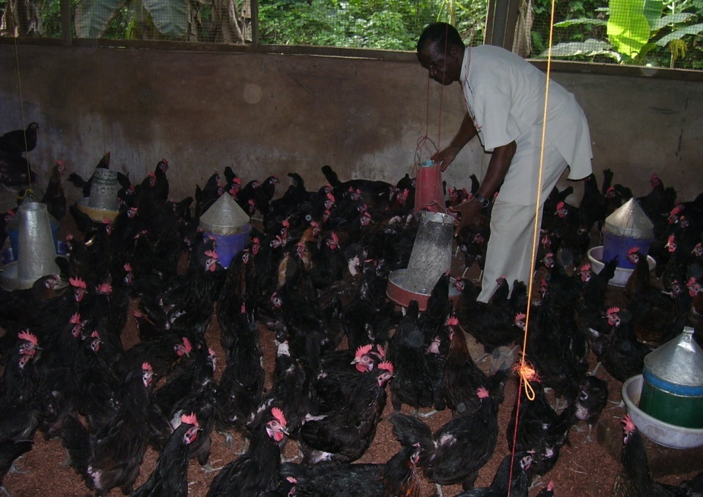
Towards establishing “Agro Centers of Excellence” in the LGAs of the State, DEVIN as part of this proposed agric initiative for peasant farmers, will further propose establishment of demonstration farms that would double as agro centers of excellence in the headquarters of the 17 LGAs or suitable locations for a replica of the Songhai farms initiative in modicum scales. The centers of excellence would be designed to incorporate crop and animal productions farms that would also serve as training centers for farmers in the State on best agro practices.
Intervention Objective-
The programme would empower rural farmers with modern agricultural techniques for increased food production in Niger State. Specifically the programme would lead to-
Provision of latest agric techniques and best practices for farmers of the State
Strategic job creation initiative for graduates of agric disciplines of Niger State origin.
Facilitation of the establishment of “Agro Centers of Excellence in line with the Songhai initiative.
Increased harvests for the peasant farmers leading to enhanced income for the farmers;
Increased food security in Niger State, etc.

Target Beneficiaries-
Two categories of beneficiaries will emerge from the programme - Primarily rural farmers (especially women) and unemployed graduates with bias in agricultural discipline (Secondary beneficiaries).
Strategy-
Unemployed agric graduates will be enlisted in the programme and their capacities will further be built to respond to the training needs of the peasant farmers. Furthermore demonstration farms would be established in the LGAs as centers of excellence to pioneer agricultural revolution in Niger State.
Activities
-Mobilization, training and deployment of unemployed agric graduates in league with Niger State Ministry of Agriculture/ADP
-Mobilisation and sensitization of rural farmers on the basis of communities and LGAs
-Deployment of Capacity building packages/ extension services by the agric graduates
-Establishment of crop and livestock demonstration farms (Agro Centers of Excellence) in LGAs of the State
Expected Outcome
-In the first year of programme implementation we anticipate that X number of Agric graduates would be deployed to communities in each of the LGAs of the State.
-In the first year X number of farmers would have been reached by the Agric graduates in each of the LGA (X number of farmers mostly women would have been reached in the State)
-In the second year of the project X number of demonstration farms (Agro Centers of Excellence) would have been established leading to an increase in the 55% of those in the agric sector.

Budget
A detailed phased budget will be determined when the number of beneficiaries to be enlisted in the scheme is known. The budget would include administrative, logistics, capacity building training, agric extension missions, setting up of demonstration farms (agro centers of excellence), programme monitoring etc
Work Plan
A time guided activity work plan (to accompany a more detailed proposal) will be presented to the Niger State government as soon as the number of beneficiaries are ascertained and approval for the programme given.

Background and Justification
Niger Youth Vocational /Apprenticeship and Enterprises Development Scheme
Low literate youths of Niger State who are bereft of technical or vocational skills are most likely to be unemployed and deprived. The future for the youths that fall under such category and classification certainly seems hopeless and bleak. Poverty would most likely be the end result of the state of dejection which confronts this class of people.  The mind set of this category of the population will most likely trigger anti social thoughts. Such minds would also be breeding grounds for criminal acts which could be unleashed on the society in the form of robberies (un-armed and armed), prostitution, kidnapping, political thuggery, etc. 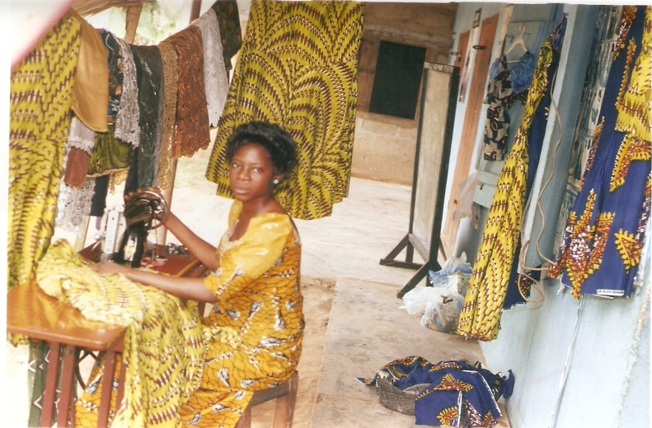The unfortunate scenario however is that many youths of Niger State are without marketable skills, just as they are low literate and unemployed.
Towards reversing this unacceptable state which significant number of youths of the State is in, a youth development programme that would focus on acquisition of lucrative technical and vocational skills by the low literate and unskilled youth population would seem plausible currently. 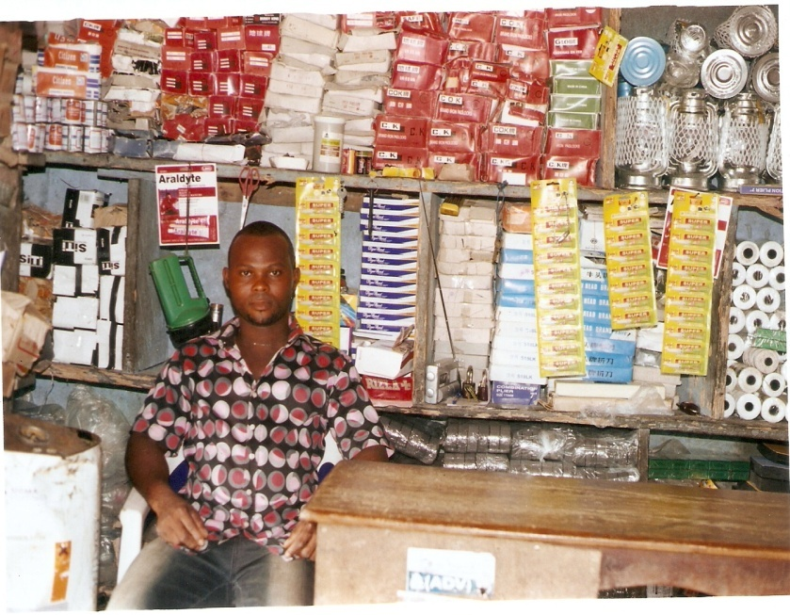Such initiative would be complimented by a robust enterprise development and employment programme to support the initiative. To this end and as part of the empowerment package designed by the Development Initiatives (DEVIN) for the people of Niger State, a Youth Vocational / Apprenticeship and Enterprises Scheme is hereby proposed as an intervention measure that would lead to acquisition of marketable skills by the selected beneficiaries and the establishment of mass entrepreneurial outfits by the youths upon completion of all trainings to be deployed under the scheme. 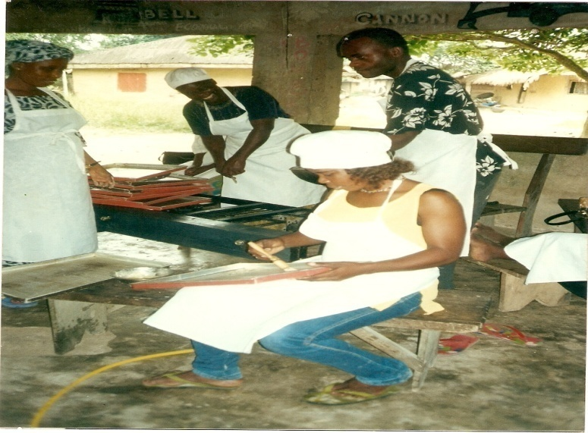
Relevant trade skills which are found to be well sought after or in high demand in parts of the State would constitute the fulcrum of the training curricula. 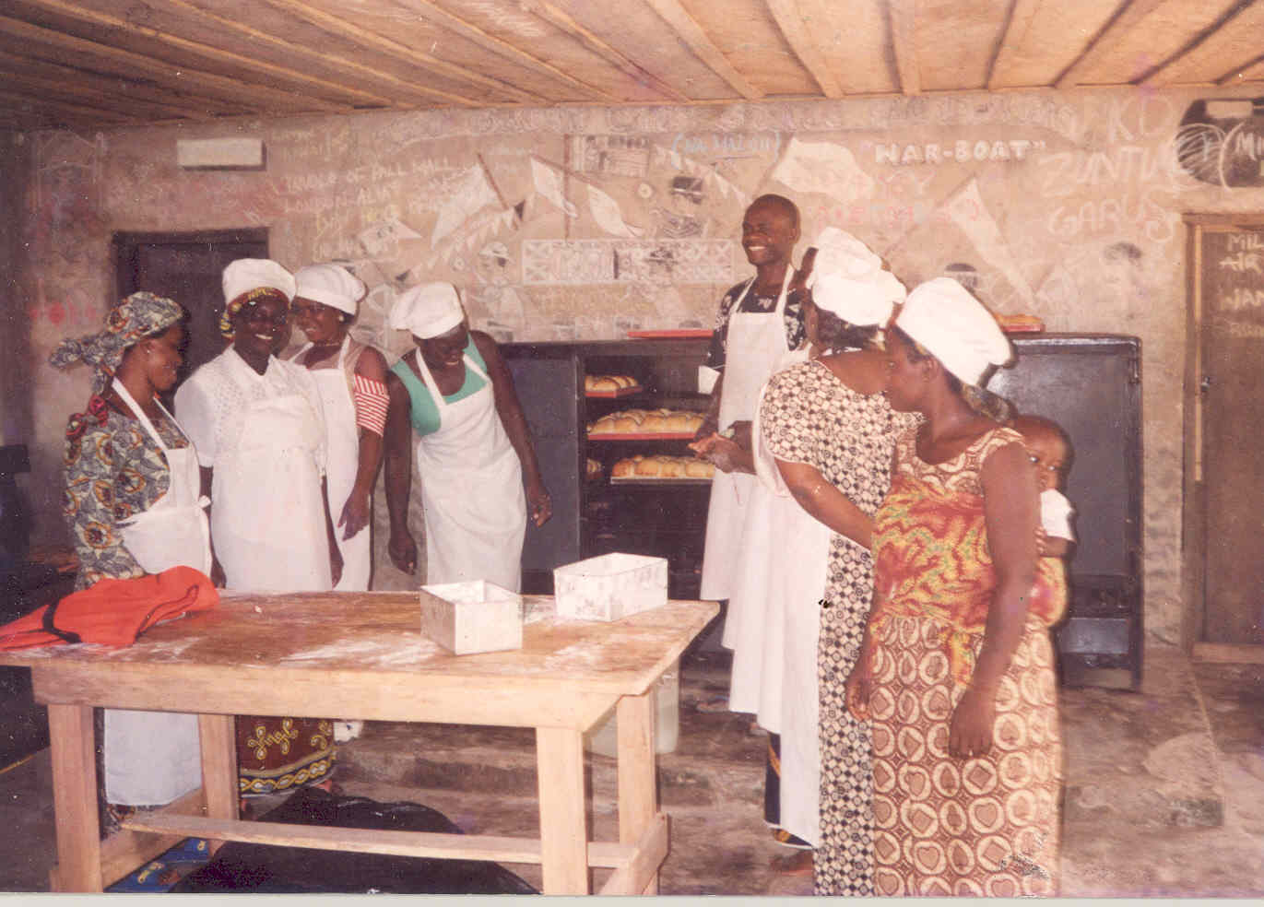The idea is that upon completion of the training requirement the youths will not have much challenges securing employment or starting of lucrative enterprises along their trade lines. DEVIN would facilitate across LGAs and communities studies that would un-ravel vocational trades which are in high demands and of which more artisans are needed. In this regard, the experience of Development Initiatives (DEVIN) in conducting similar assessments for institutions like the Niger Delta Development Commission (NDDC) would be critical in this regard.
As has been noted above, technical / vocational skills training will be complimented by sustainable entrepreneurial and employment programme that would erode idleness on the part of the youths and result in reduction of poverty amongst the beneficiaries.
Intervention Objective-
The scheme aims at empowering low literate and unskilled youths to engage in thriving entrepreneurial activities for the soci-economic development of the State. Specifically the programme would achieve the under listed specific objectives –
Mobilization and training of low literate and unskilled youths of Niger State on lucrative vocational / technical training
Provision of small management training for the beneficiaries towards preparing them for life in entrepreneurial pursuits
Facilitating the establishment of small businesses by the youths
Commence a process of attitude re-orientation and mind set change programme for the youths
Facilitate an employment programme for youths who do not have dependable entrepreneurial aptitude, etc.
Target Beneficiary-
Low literate and unskilled youths of Niger State
Strategy-
Provide technical and small business management training for selected youths and initiate entrepreneurial development programme
Activities
-Mobilize target youths on LGA by LGA basis
Carry out an assessment of demands of vocational trades on LGA by LGA basis towards determining artisan skills that are in high demand
-Identify and facilitate the participation of training centers / businesses
-Attach youths to the centers and flag off training
Set up and regularize workshops for small business management training for the youths
-Form successfully trained youths into credit associations as initial steps to accessing resources to establishing small businesses
Expected Outcome
-First year X number of youths (X number per LGA will be trained in various technical / vocational skills
-Same number would have been empowered with skills in small business management
-In the second year more than one third of the beneficiaries would receive assistance to establish own enterprises
-Mid way in the second year about X businesses would have been set up in each LGA of Niger State
Budget
A detailed phased budget will be determined when the number of beneficiaries to be enlisted in the scheme is known. The budget which includes administrative, logistics, vocational / technical training, small business management training, setting up of small businesses for the scheme participants, programme monitoring etc
Work Plan
A time guided activity work plan (to accompany a more detailed proposal) will be presented to the Niger State government as soon as the number of beneficiaries are ascertained and approval for the programme given.

Background and Justification
Niger Low Income Women Enterprise Support Scheme
One of the cardinal objectives of Community Empowerment Initiatives is the empowerment of the poor and stimulation of the growth of the rural economy of a given area. The Development Initiatives (DEVIN) affirms that this could be achieved through the provision of needed financial services that would enable the membership of community based groups especially women organizations to engage in or expand their present scope of economic activities and also generate employment. 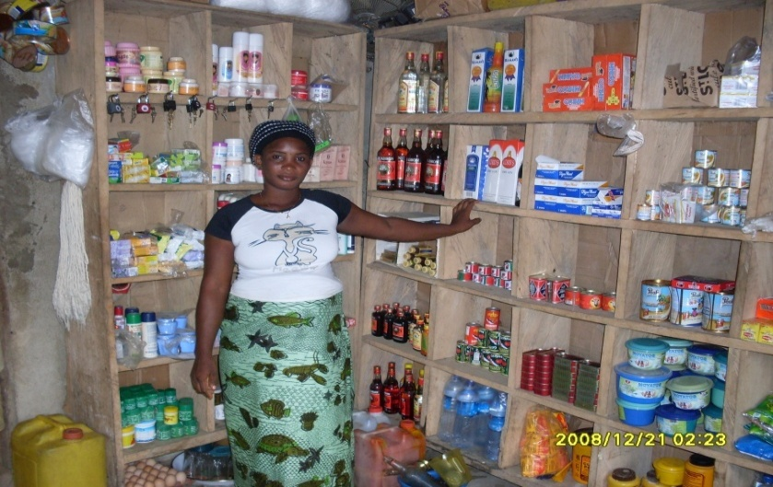Micro finance scheme for the low income women of Niger State would promote enterprises development as recipients of micro loans invest in productive ventures that generate income. The Development Initiatives (DEVIN) is convinced that sustainable micro finance initiative is a trusted instrument of economic growth for poor rural areas and if well designed and implemented would yield tangible results that would drive sustainable poverty reduction initiatives. Using the community based women groups as bases / vehicles to realizing the scheme objective, DEVIN’s micro credit programme would use the approach of collective appraisal of loan applications, loan utilization tracking and monitoring and peer pressure cross guarantee to enforce repayment. Since savings would constitute a critical adjunct of the scheme being proposed by DEVIN, it will be facilitated in such a way that it would assist borrowers to build own capital and also act as security for credit facilities obtained under Niger State Empowerment Programme.

The Development Initiatives (DEVIN) would adopt tested strategies for effective savings and credit purveyance. In designing and implementing the credit scheme for the women of Niger State, a deliberate effort will be made to focus on low income women entrepreneurs since they constitute majority of those who should be assisted to lift themselves out of poverty. In this regard, enterprising widows and such vulnerable groups would be encouraged to participate in the scheme. Most households in the State are female- headed and therefore supports to these bread winners would extensively address wide spread poverty in the State. Through women based groups in the communities of the LGAs DEVIN would facilitate the process of mobilizing the scheme participants, sensitizing them, building their capacities on loan utilization/ repayment and small business management, mobilizing savings, etc. 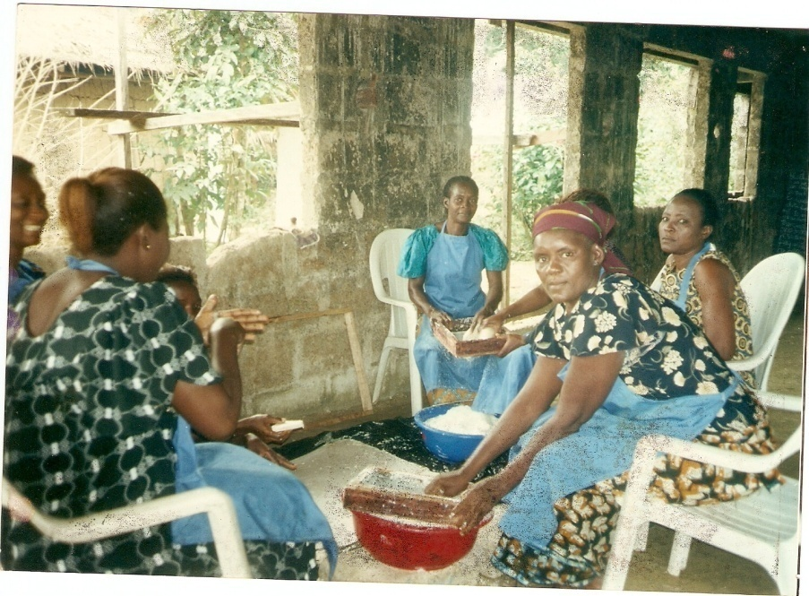Every aspect of the initiatives will be monitored and evaluated constantly towards ensuring compliance with scheme objectives.
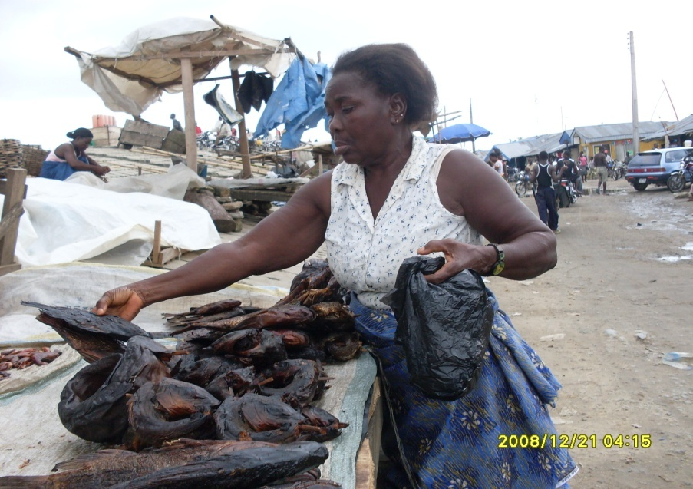

Scheme’s Approach hinged on Sustainable Savings Structure
Culture of savings and investments would be instilled in the scheme participants, as the framework for implementing the scheme would be akin to the Village Savings and Loan Association (VSLA) framework and DEVIN would facilitate the formation of Associate Savings and Credit Associations (ASCAs) by the participants. The ASCAs will be meeting regularly as they will deem fit and in these meetings savings will be mobilized and credit given out as need for such arises and as agreed by the groups. The tenets of the VSLA framework would be part of the capacity building activities to be facilitated for the groups by DEVIN.
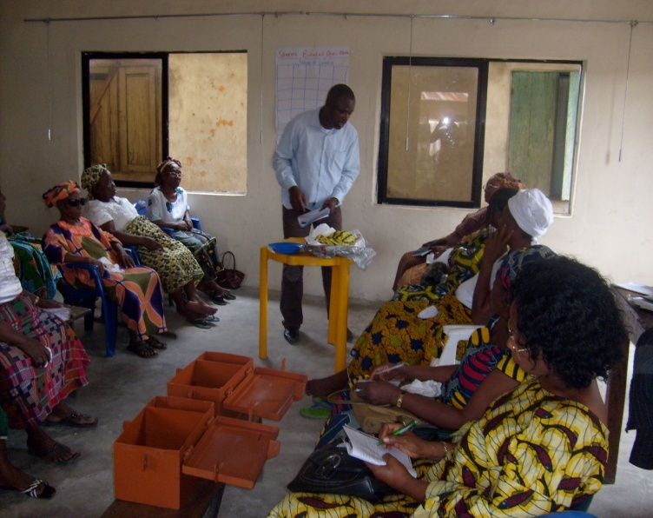
Target Beneficiary-
Low income women especially widows and other vulnerable groups
Intervention Objective-
The programme aims at providing sustainable micro finance scheme for low income women of Niger State towards supporting micro and small businesses in Niger State. Specifically the scheme will achieve the following objectives-
Create opportunities emergence and expansion of hundreds of micro and small enterprises through provision of thriving savings and credit
Train low income women on management of micro and small businesses
Build the capacity of the target beneficiaries on the principles of Village Savings and Loan (VSLA) framework
Administer micro credits towards supporting hundreds of micro and small enterprises in Niger State
Monitor Enterprises of loan beneficiaries / track repayments
Strategy-
Sustainable mobilization and Capacity building through the VSLA framework and Credit provision for enterprises development
Activities-
-Mobilising and facilitating the formation of women into ASCAs and other economic groups
-Mind set change activities
-VSLA Capacity building / Enterprises development trainings
-Strategic credit administering programme for the ASCAs
-Enterprises tourisms / Mentoring activity
Expected Outcome-
-In the first implementation year at least X number ASCA groups would have been mobilised in each of the LGAs of the State.
-In each LGA at least X number of women would have been enlisted and trained in the VSLA programme in the first year.
-By the end of the second year hundreds of new businesses and existing ones would have been supported by the programme
Budget
A detailed phased budget will be determined when the number of beneficiaries to be enlisted in the scheme is known. The budget which would include administrative, logistics, vocational / technical training, small business management training, setting up of small businesses for the scheme’s participants, programme monitoring etc,

Work Plan
A time guided activity work plan (to accompany a more detailed proposal) will be presented to the Niger State government as soon as the number of beneficiaries are ascertained and approval for the programme given.

PROGRAM IMPLEMENTATION METHODOLOGY AND STEPS APPLICABLE TO THE NIGER STATE EMPOWERNMENT PROGRAMME
Towards realizing the overall goal of the project, the Development Initiatives (DEVIN) will adopt a robust implementation strategy capable of delivering the planned activities towards achieving the Niger State Empowerment Programme project strategic objectives. The methodology and steps proposed here is based on our understanding of the requirements of Work to be accomplished, as well as our analyses of the overall interventions’ conceptual framework.
Program Pre Implementation Activities
DEVIN conceptualizes the pre program implementation activities as steps which will serve as frames towards establishing formidable and enduring structure for a successful program implementation. It is expected that the activities will be firmed up within four weeks of signing the project implementation contract or MOU with the government of Niger State.
Pre Project Implementation Meeting
In the bid to ensuring a smooth take off of the programme, DEVIN would as initial activity steps, meet with the Niger State and other government representatives towards, reviewing and having a common understanding of the program’s conceptual frame work and proposed strategies and activities, to realizing project set goals. Based on the outcome of the deliberation and other emerging issues a revised outline of activities, strategies and work plan may become necessary. It is hoped also that during this meeting final decision about the Local Government Areas that would benefit from the program would be taken.
Recruiting and Constituting Project Team
Upon completion of all necessary amendments DEVIN will immediately commence recruitment / secondment process of the project team members for immediate deployment. The category of resource persons to be deployed as project team members includes DEVIN serving staff, new staff and consultants. The project team which would include indigenes of Niger State will be broadly categorized into-
(1) Administrative personnel
(2) Baseline Survey / Gap Inventory Activities Personnel
(3) Capacity Building Training Personnel
(4) Enterprises Development /other Programme Field Personnel
As part of DEVIN’s operational principle, the organisation will engage highly qualified and experienced resource persons to constitute the project team.

Notes:

